**PYTHON PROGRAMMING ACTIVITY #3**

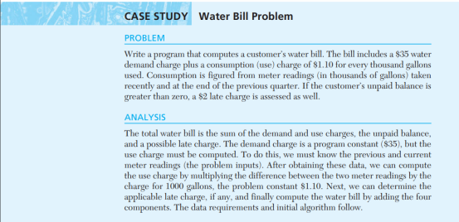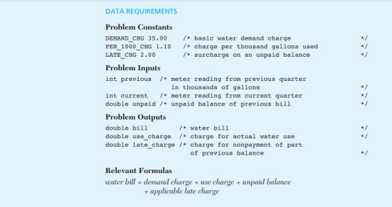**SAMPLE RUN OF THE WATER BILL PROGRAM:**

Enter unpaid balance> **Php71.50**

Enter previous meter reading> **4198**

Enter current meter reading> **4238**

Bill includes Php2.00 late charge on unpaid balance of **Php71.50**

**Total Due = Php152.50**